# Phase 4: Process Automation (Admin)

## Salesforce Edition

Edition Used: Developer Edition is used.

Reason: Developer Edition supports full automation features (Validation Rules, Workflow, Process Builder, Flows, Approval Processes) without additional licensing. Ideal for ShopSmart project.

## Validation Rules

Purpose: Ensure data integrity and enforce business rules.

|  |  |  |  |
| --- | --- | --- | --- |
| Object | Rule Name | Formula | Error Message |
| Opportunity | VR_CloseDate_Not_Past | CloseDate < TODAY() | Close Date cannot be in the past. |
| Opportunity | VR_Discount_Cap | AND(NOT($Permission.Approve_High_Discount), Discount__c > 30) | Discount cannot exceed 30% without manager approval. |
| Order | VR_Require_Shipping_Address | AND(ISPICKVAL(Delivery_Type__c,"Ship"), ISBLANK(Shipping_Address__c)) | Shipping address is required for non-pickup orders. |
| Product | VR_SKU_Format | NOT(REGEX(SKU__c,"[A-Z]{3}-[0-9]{4}")) | SKU must be in format AAA-1234. |

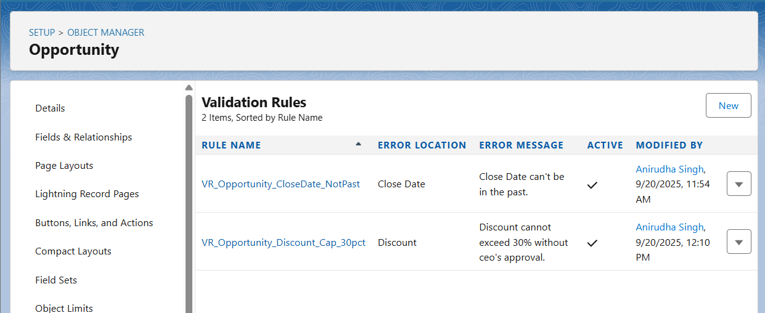

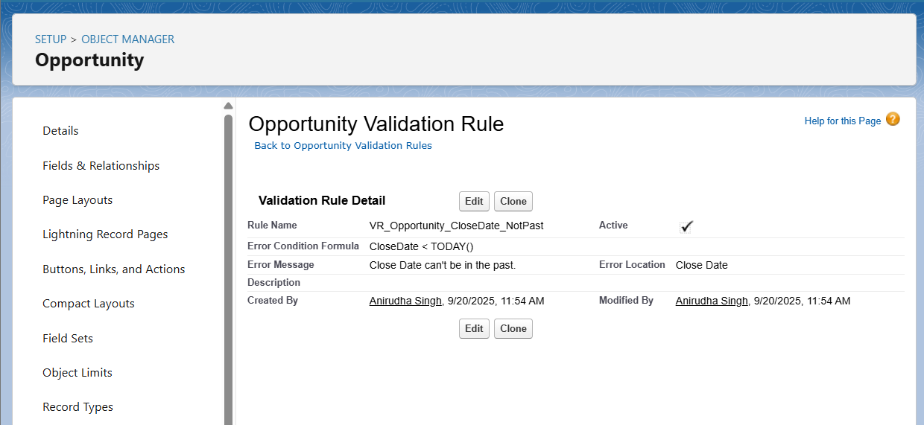

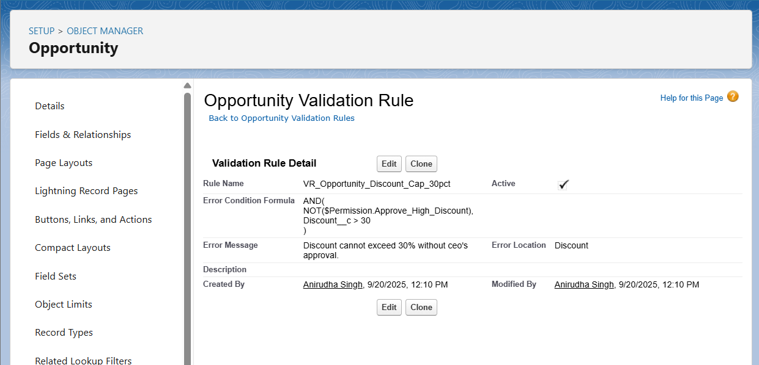

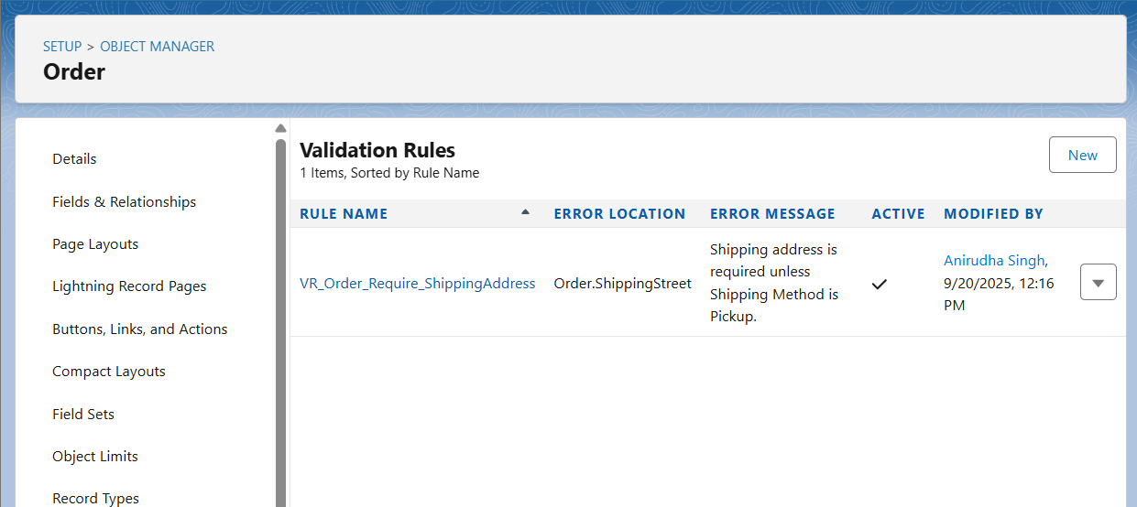

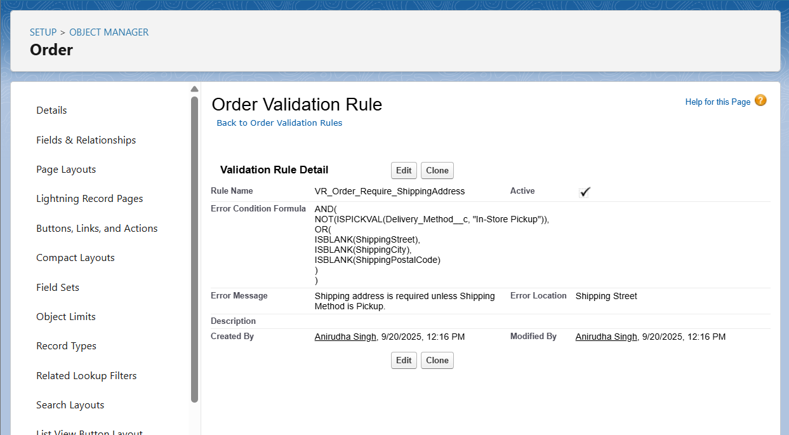

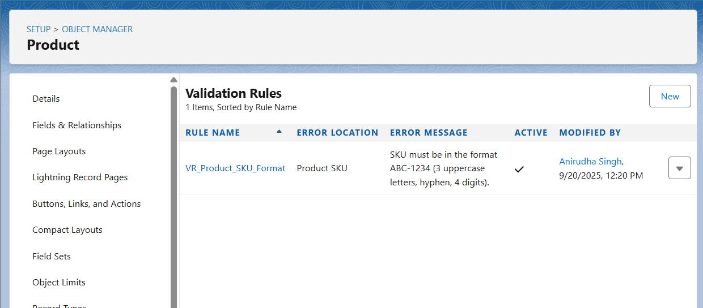

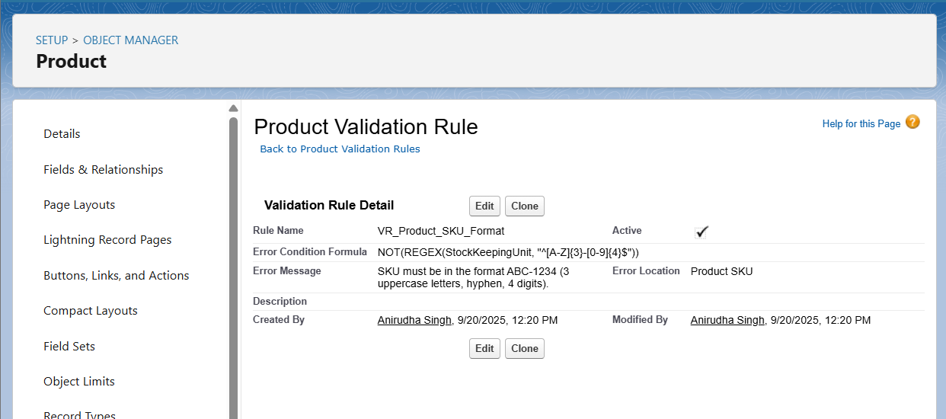

## Workflow Rules

Purpose: Automate simple actions (Task creation, Email alerts, Field updates).

Example: High-Value Opportunity Task

- Object: Opportunity  
- Criteria: Amount > 100000  
- Immediate Actions:  
 • Create Task → Assigned to Opportunity Owner, Subject: Follow-up High-Value Opportunity, Due Date = Today + 1, Status = Not Started  
 • Email Alert → Template: HighValueOpportunityAlert, Recipient: Opportunity Owner

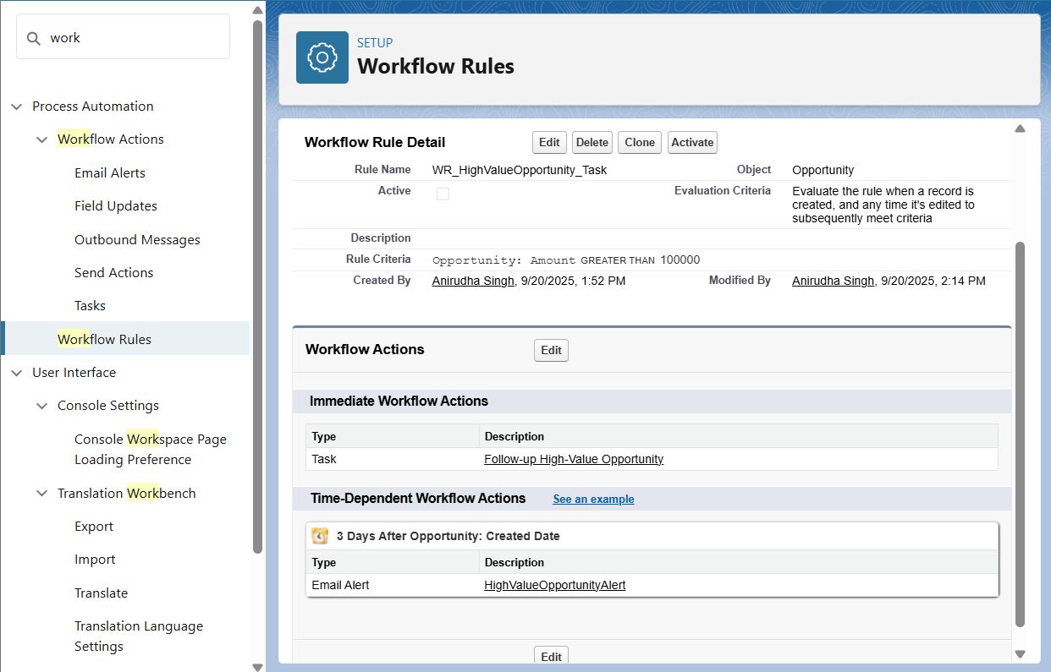

## Process Builder

Purpose: Automate multi-step processes with more flexibility than Workflow Rules.

Example: High-Value Opportunity Process  
- Object: Opportunity  
- Trigger: Created or Edited  
- Criteria: Amount > 100000  
- Immediate Actions:  
 • Create Task (same as workflow)  
 • Send Email Alert (HighValueOpportunityAlert)

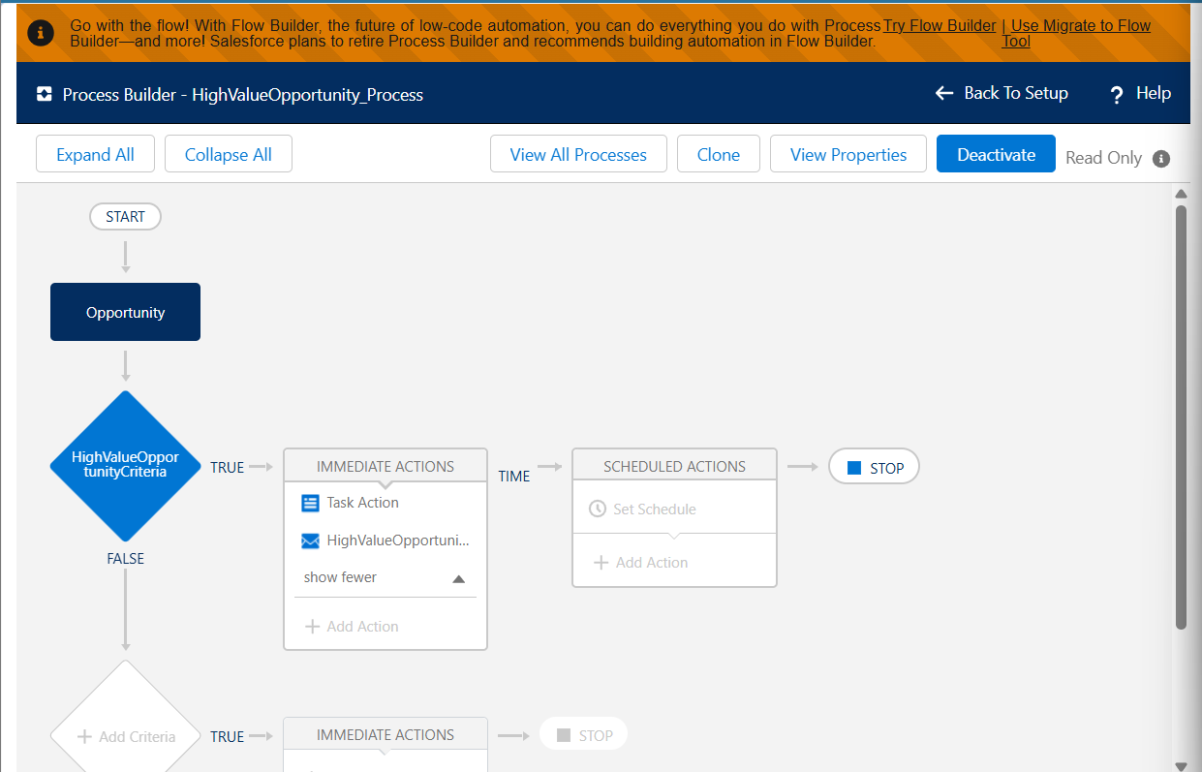

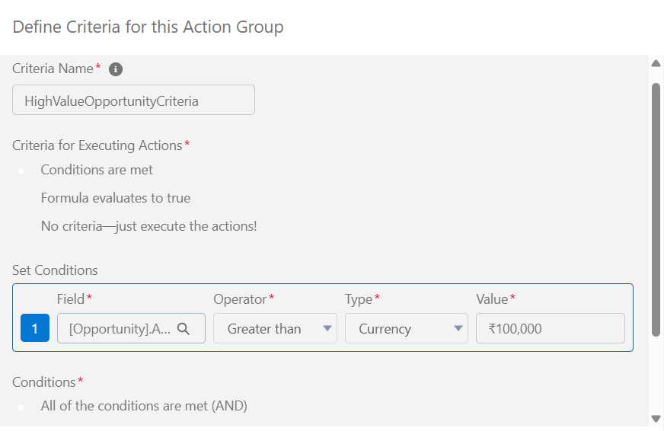

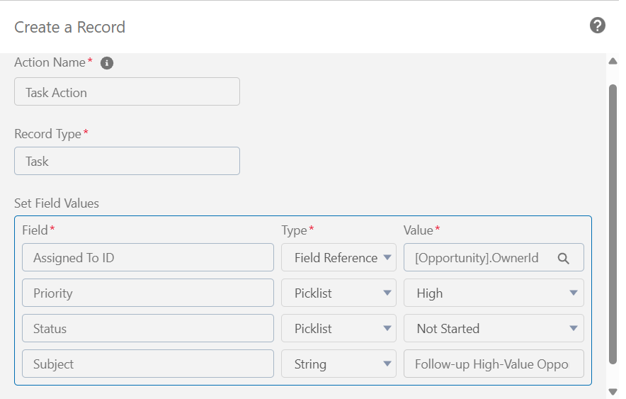

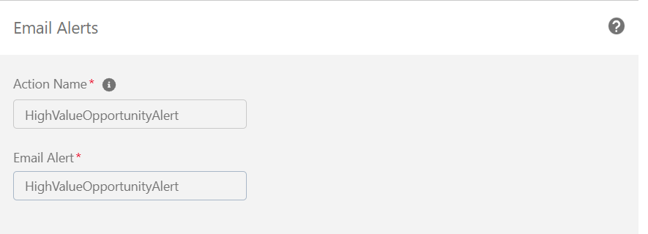

## Approval Processes

Purpose: Automate record approvals for compliance or business rules.

Example: High Discount Approval  
- Object: Opportunity  
- Entry Criteria: Discount__c > 30  
- Approver: Opportunity Owner’s Manager  
- Initial Actions: Lock record, notify approver  
- Approval Actions: Unlock record, optional Field Update → Discount_Approved__c = TRUE  
- Rejection Actions: Unlock record, notify owner, optional Field Update → Discount__c = 30

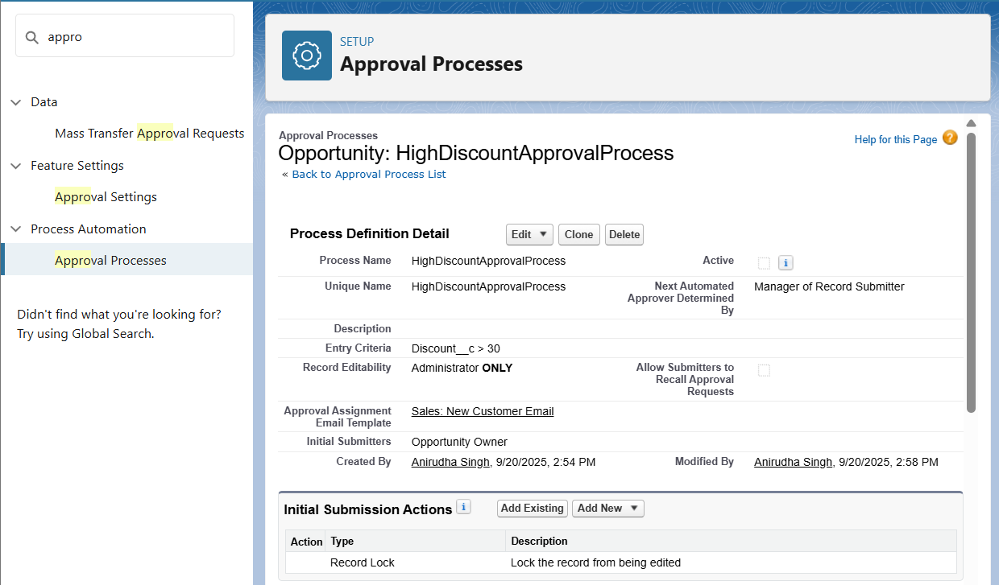

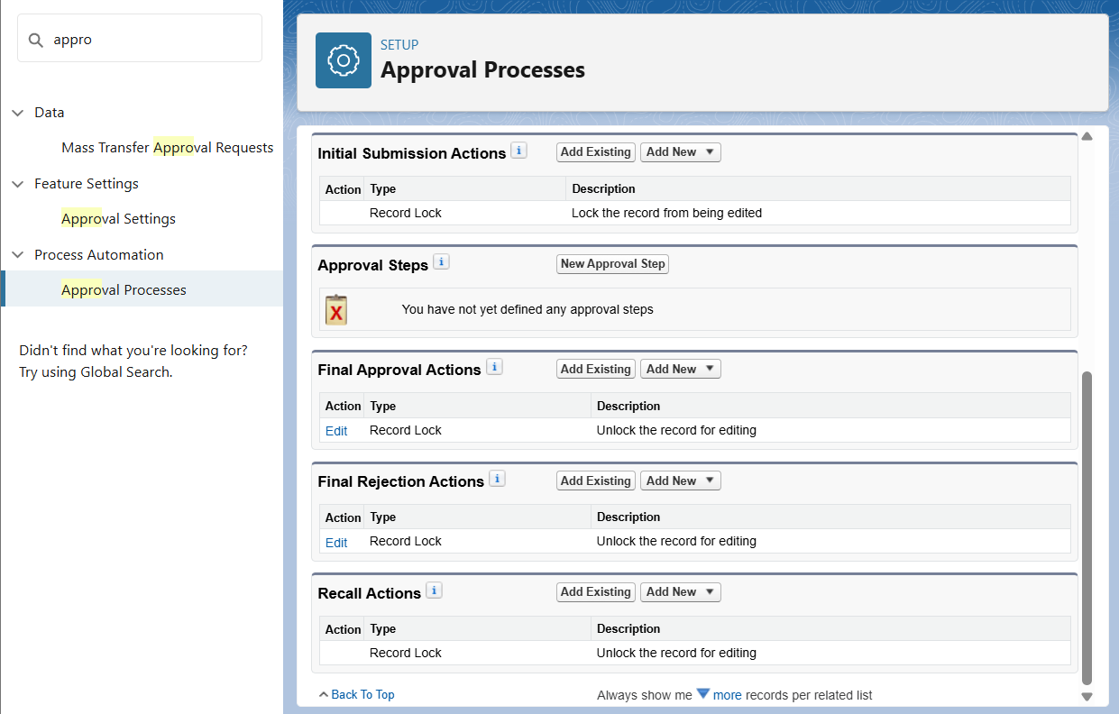

## Flow Builder

Purpose: Advanced automation to create, update, and interact with records.

Example: Record-Triggered Flow – High-Value Opportunity  
- Trigger: Record Created or Updated  
- Condition: Amount > 100000  
- After Save Actions:  
 • Create Task → Subject: Follow-up High-Value Opportunity, Due Date = $Flow.CurrentDate + 1, Status = Not Started  
 • Send Email Alert → Template: HighValueOpportunityAlert

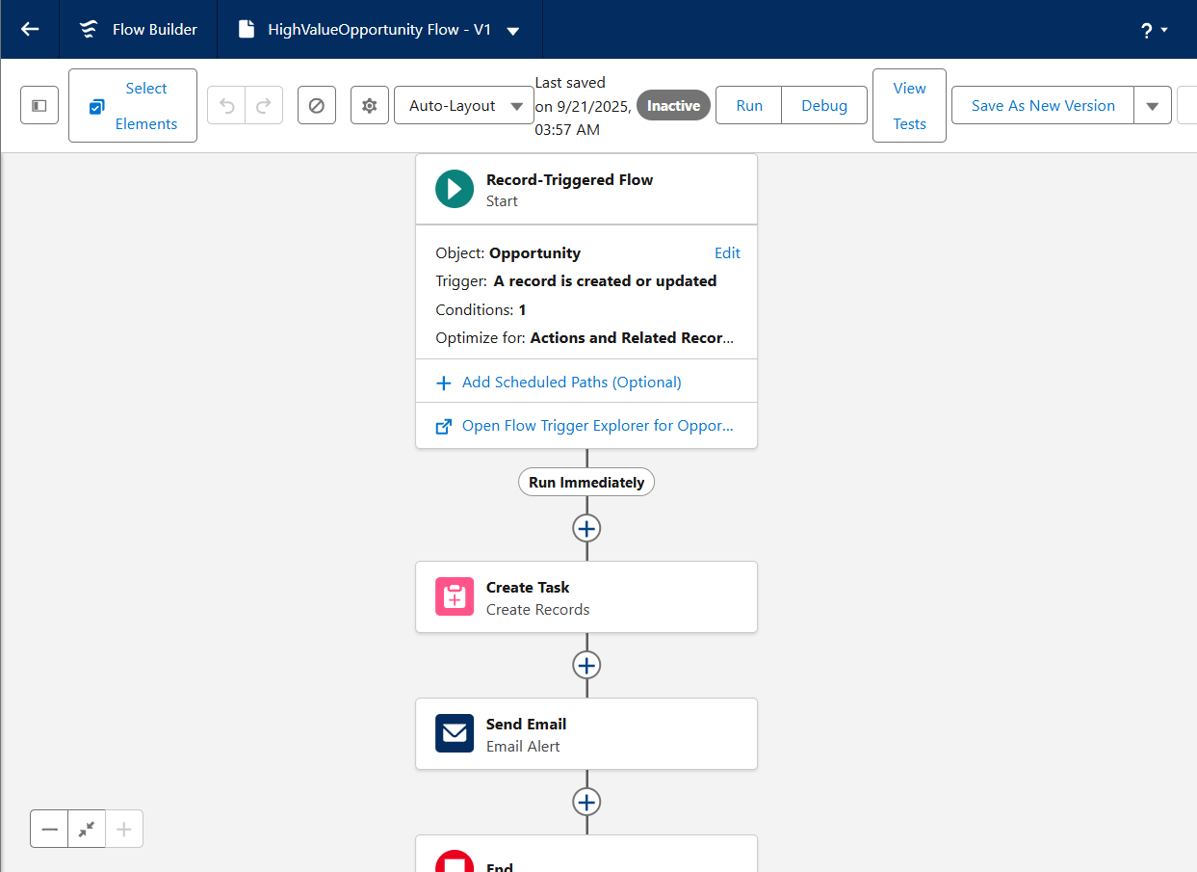

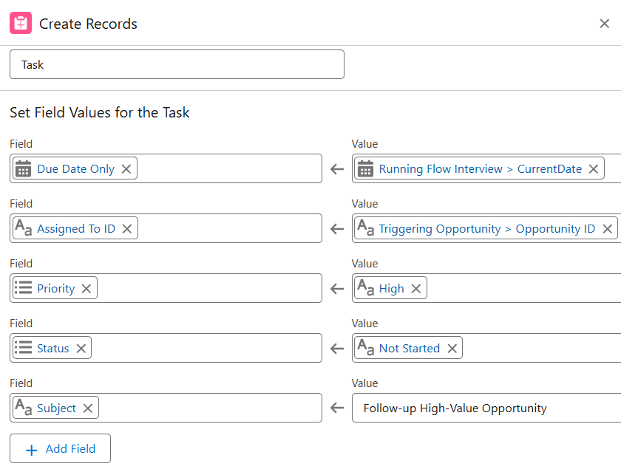

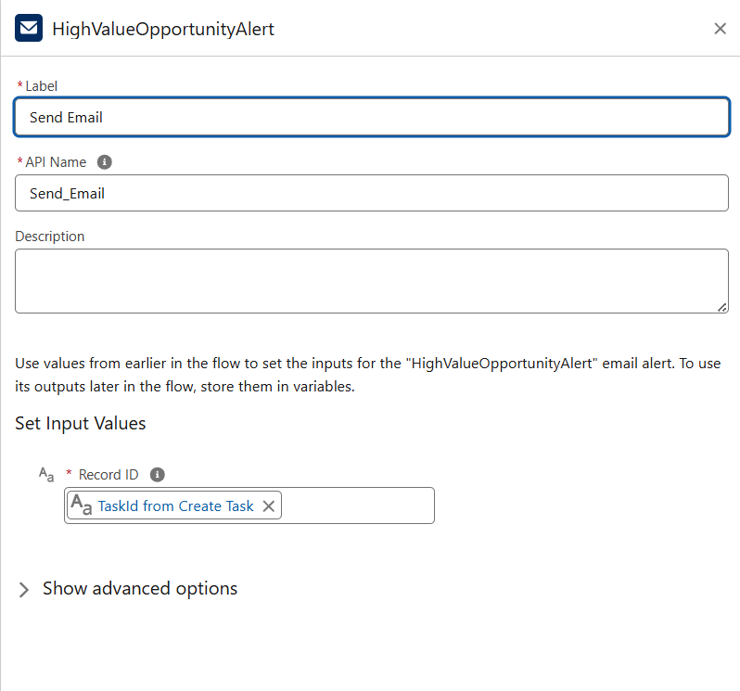

## Email Alerts

Purpose: Notify users automatically via email.  
- Template: HighValueOpportunityAlert  
- Recipients: Opportunity Owner (mandatory), optional: Sales Manager or Role  
- Usage: Attached to Workflow Rule, Process Builder, or Flow

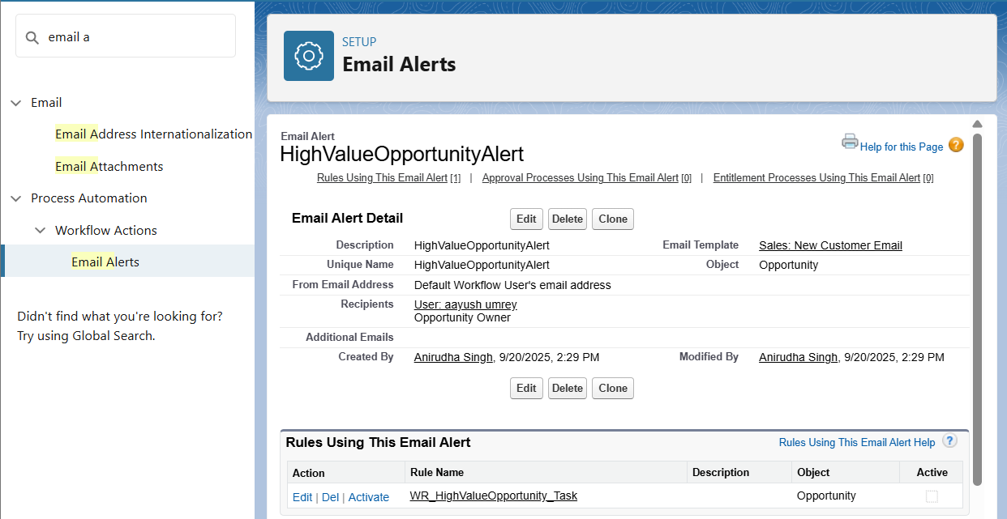

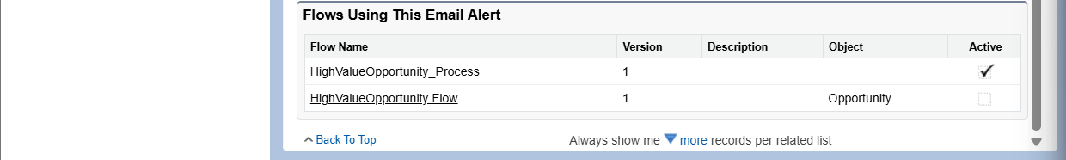

## Field Updates

Purpose: Automatically update field values.  
- Examples:  
 • Opportunity → High_Value__c = TRUE when Amount > 100000  
 • Order → Status automatically set to Processing when submitted

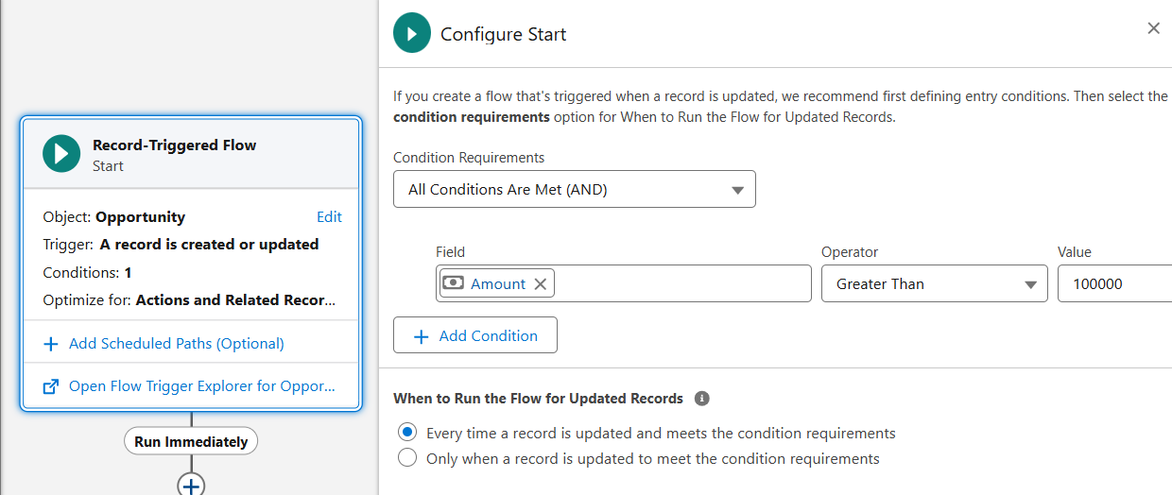

## Tasks

Purpose: Automatically assign follow-up tasks.  
- Covered in Workflow, Process Builder, and Flow Builder examples.

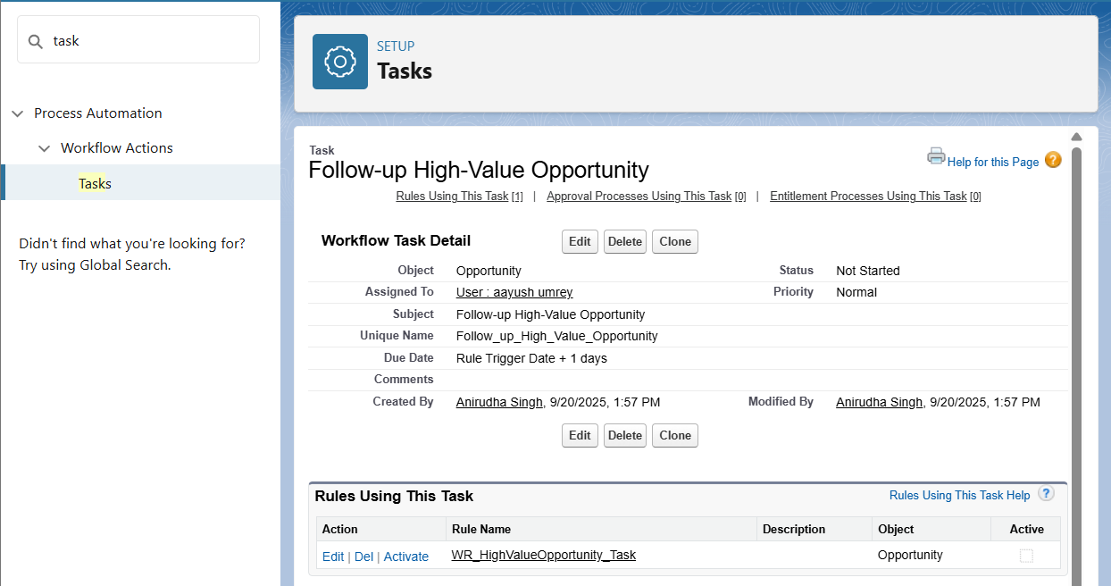

## Custom Notifications

Purpose: Notify users in-app and via mobile for important events.  
- Example: Notify Sales Manager when a high-value order is submitted.  
- Steps:  
 • Setup → Custom Notifications → New → Name: High_Value_Order_Notification  
 • Add to Flow/Process → Action: Send Custom Notification → Recipient: Role/User → Message: “High-value order submitted: {!Order.Name}”

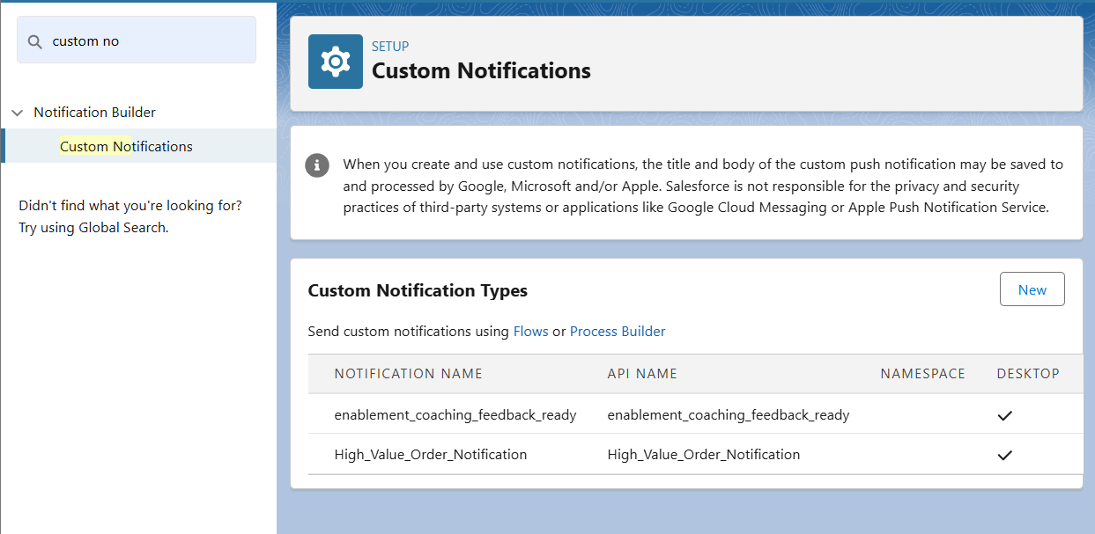  
Optional enhancements like multi-step approval or advanced recipient roles can be added later.